Set Up the Preview

To develop apps for the Android N Preview, you need to make some updates to your developer environment, as described on this page.

To simply test your app's compatibility on the Android N system image, follow the guide to [Test on an Android N Device](https://developer.android.com/preview/download.html).

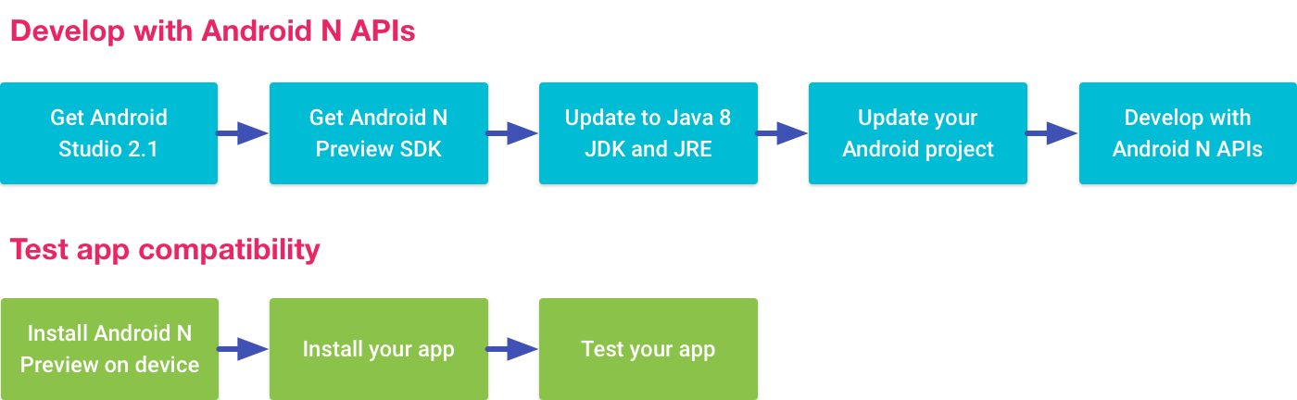

Get Android Studio 2.1

The Android N platform adds support for [Java 8 language features](https://developer.android.com/preview/j8-jack.html), which require a new compiler called Jack. The latest version of Jack is currently supported only in Android Studio 2.1. So if you want to use Java 8 language features, you need to use Android Studio 2.1 to build your app. Otherwise, you don't need to use the Jack compiler, but you still need to update to JDK 8 to compile against the Android N platform, as described below.

If you already have Android Studio installed, make sure you have Android Studio 2.1 or higher by clicking **Help > Check for Update** (on Mac, **Android Studio > Check for Updates**).

If you don't have it, [download Android Studio 2.1 here](https://developer.android.com/studio/).

Get the N Preview SDK

To start developing with Android N APIs, you need to install the Android N Preview SDK in Android Studio as follows:

1. Open the SDK Manager by clicking **Tools > Android > SDK Manager**.
2. In the **SDK Platforms** tab, select the **Android N Preview** check box.
3. Click the **SDK Tools** tab, then select the **Android SDK Build Tools**, **Android SDK Platform-Tools**, and **Android SDK Tools** check boxes.
4. Click **OK**, then accept the licensing agreements for any packages that need to be installed.

Get the N Preview reference documentation

Beginning with the Preview 4 release, the API reference for the N platform (API level 24) is now available online at [developer.android.com/reference/](https://developer.android.com/reference/). There is also an incremental diff report for [API changes between API levels 23 and 24](https://developer.android.com/sdk/api_diff/24/changes.html).

Get the Java 8 JDK

To compile your app against the Android N platform and use some tools with Android Studio 2.1, you need to install the Java 8 Developer Kit (JDK 8). So, if you don't already have the latest version, download JDK 8 now.

Then set the JDK version in Android Studio as follows:

1. Open an Android project in Android Studio, then open the Project Structure dialog by selecting **File > Project Structure**. (Alternatively, you can set the default for all projects by selecting **File > Other Settings > Default Project Structure**.)
2. In the left panel of the dialog, click **SDK Location**.
3. In the **JDK Location** field, enter the location of the Java 8 JDK (click the button on the right to browse your files), then click **OK**.

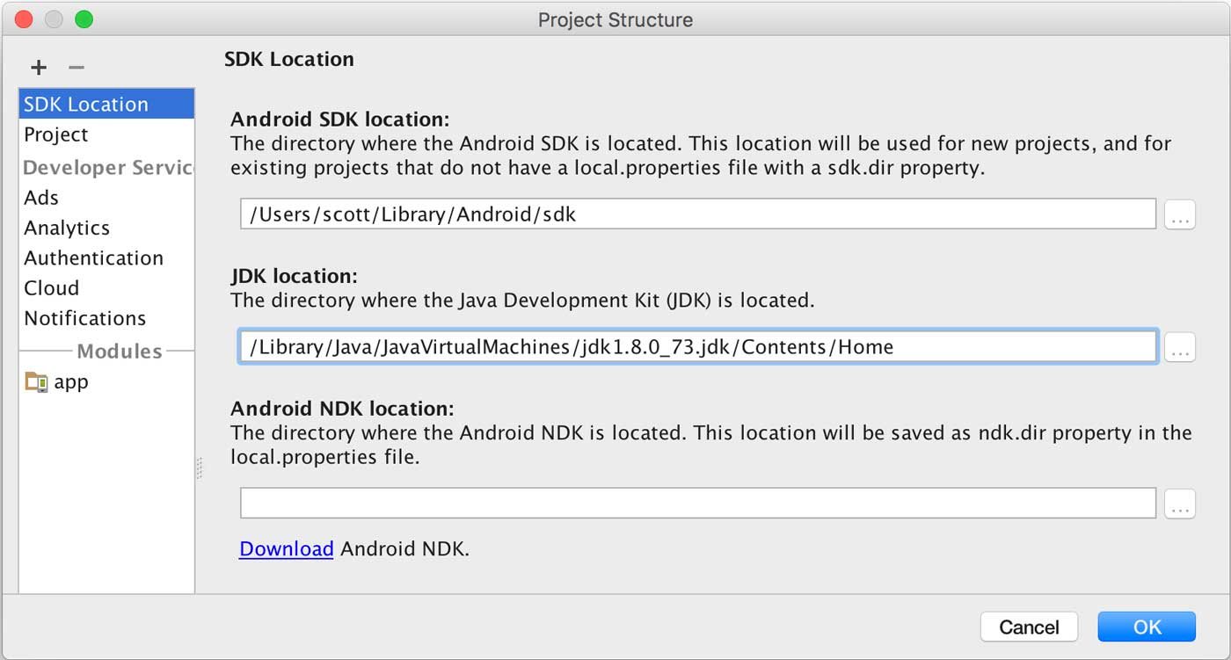

Update or Create a Project

Now that the N platform API level is "24" instead of "N", you can configure your projects normally with this API level (and even publish your apps compiled with API 24 on Google Play). Just be sure that you've updated your project to use **Android SDK Build Tools 24.0.0** and **Android SDK Platform-Tools 24.0.0**.

If you plan to use Java 8 language features, you should also read [Java 8 Language Features](https://developer.android.com/preview/j8-jack.html) for information about the supported Java 8 features and how to configure your project with the Jack compiler.

Update an existing project

Open the build.gradle file for your module and update the values as follows:

android {  
  compileSdkVersion **24**  
  buildToolsVersion **'24.0.0'**  
  ...  
  
  defaultConfig {  
     targetSdkVersion **24**  
     ...  
  }  
  ...  
}

Now that the API level 24 is final, you can compile against it and keep your minSdkVersion to whatever version is appropriate for your app.

Create a new project

To create a new project for development with the Android N Preview SDK:

1. Click **File > New Project**. and follow the steps until you reach the **Target Android Devices** page.
2. On this page, select the **Phone and Tablet** check box.
3. Under **Phone and Tablet** option, in the **Minimum SDK** option list, select **API 24: Android 6.X (N Preview)**.

Next Steps

* Follow the guide to [Test on an Android N Device](https://developer.android.com/preview/download.html).
* Learn more about the Android N platform with [Behavior Changes](https://developer.android.com/preview/behavior-changes.html) and [Android N APIs and Features](https://developer.android.com/preview/api-overview.html).